Less-Known Supporters of Workplace Democracy

David P. Ellerman and Tej Gonza
Institute for Economic Democracy
Ljubljana, Slovenia

Abstract
This paper collects together extensive quotations and extracts from 19th and 20th century thinkers (almost all dead white men) who were little-known for being supporters of workplace democracy.

Table of Contents
Introduction
Alexis de Tocqueville (1805-1859)
John Stuart Mill (1806-1873)
Senator Leland Stanford (1824-1893)
Henry Carter Adams (1851-1921)
Henry Wickham Steed (1871-1956)
Robert S. Brookings (1850-1932)
Lord Eustace Percy (1887-1958)
Sir Alfred Eckhard Zimmern (1879–1957)
Alfred Marshall (1842-1924)
John Dewey (1859-1952)
Paul Douglas (1892-1976)
Arthur Cecil Pigou (1877-1959)
Jacques Maritain (1882-1973)
George P. Brockway (1916–2001)
Owen D. Young (1874-1962)
Ernst Johannes Wigforss (1881–1977)
Bertrand Russell (1872-1970)
Justice Louis D. Brandeis (1856-1941)
Edwin G. Nourse (1883-1974)
Harry von Eckermann (1886–1969)
Robert Dahl (1915-2014)
William Greider (1936-2019)
Carole Pateman (1940-)
Noam Chomsky (1928-)
Concluding Remarks

Introduction
Workplace democracy is an old idea. Its main principle is simple and straightforward; each private firm should be a democratic organization, a small republic whose citizens are the people working in it. This idea has surfaced again and again over the last century and half, but is still little known. Workplace democracy, in its essence, is based on the abolition of the employment relation, the hiring, employing, renting, or leasing of people. If the renting of people is abolished, then there can only be “labor hiring capital” in workplace democracies instead of “capital hiring labor” in today’s human rental firms.
However, for over a century, “The Alternative” to the current system has not been the abolition of human rentals but rather the nationalization or socialization of employment in some system of governmental socialism. The dichotomy of private versus public employment (rather than the abolition of employment) was crystallized after Marx, Lenin, the Russian Revolution, and the international communist movement. Socialism promised to “extend democracy to the workplace” which in theory and clearly in practice meant extending political democracy (where it existed) to include ownership of all firms of any significant size—which is quite different from the vision of private firms themselves becoming democratic polities.
Since World War II, the Cold War between “Capitalism” and “Communism” seemed like an updated version of the Peloponnesian War between Athens, which had privately owned slaves, and Sparta, which has publicly owned slaves. The idea of abolishing both the private and public ownership of other people was not then on the mainstream political or theoretical agenda.
Over the last century, the idea of abolishing both the private and public renting or employing of people was essentially absent from the public agenda. We think this is largely responsible for the TINA’s victory – in its economic role, state socialism lost the war against the market, and one can hardly expect its revival. Today, every attempt on the Left is easily dismissed by having it designated as nostalgic attempt to re-establish the old state socialist ideals. Yet throughout all the decades of dichotomized thinking, “capitalism” versus “socialism/communism,” a wide variety of independent and non-sectarian thinkers enunciated the vision of workplace democracy. The purpose of this paper is to collect together those isolated voices and to let them speak for themselves through extended quotations or excerpts from their writings.

Alexis de Tocqueville (1805-1859)

Tocqueville was born to a French aristocratic family. He was harsh opponent of the monarchy that ended with the Revolution and considered himself a classical liberal. While in Parliament, he sat on the center-left. He showed special interest in the rise of industrialism in Europe and America. His major book, Democracy in America, is best known for his emphasis on associations and what might be called New England town meetings democracy.
In his unfinished Second Memoir on Pauperism, Tocqueville promoted democratization of ownership; to lift the agricultural peasanty out of poverty and subjection, he recommended the spread of land ownership to the agricultural workers, and to lift the industrial working class out of the same conditions, he thought the same should be done with capital ownership.
The practical problem to be solved was consequently this: to ﬁnd a modern equivalent for workers to landownership. Tocqueville had several ideas as to how to accomplish this. One was to allow workers to own parts of the place where they worked. They could also join together and run a business on their own and, in this way, bypass the traditional ownership structure. [Swedberg, Richard. 2009. Tocqueville’s Political Economy. Princeton: Princeton University Press. p. 142]
In speculating why he never finished the Second Memoir, Swedberg notes how Tocqueville’s argument may have pulled him further left than he desired at the time.
The advocacy of worker-owned corporations, for example, put him in the company of Buchez, Proudhon, and other advocates of workers’ rights with whom he did not want to be associated. The logic of his argument—to own property is good, and workers should therefore own property—may have pushed Tocqueville further to the left than he wanted. [Ibid., p. 143]
All the Tocqueville quotes are from the 1837 Second Memoir on Pauperism (unpublished translation by Christine Dunn Henderson). The original French text is: Tocqueville, Alexis de. 1837. “Second Memoir on Pauperism.” In Oeuvres, XVI, 140-57.
In my opinion the crux of the problem to be solved is this: To find a means of giving the worker the small farmer's spirit and habits of property ownership.
But Tocqueville considers that the only way for workers to acquire such an interest in an existing factory is for the "industry's capitalist entrepreneurs…to give their workers a proportionate amount of the profits or to contribute to the company small sums which could be shared with the workers." [Second Memoir]
While Tocqueville thinks that the capitalists should make such gifts in their own interest, he finds little inclination for them to do so. He hoped for this ultimate form of industry, he didn't think the time was ripe in his own time (1837).
Nevertheless, I am led to believe that a time is approaching when a large number of industries might be run in this manner. As our workers gain broader knowledge and as the art of joining together for honest and peaceful goals makes progress among us, when politics does not meddle in industrial associations and when government, reassured about their goals, does not refuse them its benevolence and its support, we will see them multiply and prosper. In democratic ages like ours, I think that associations of all sorts must gradually come to take the place of the commanding action of a few powerful individuals. It thus seems to me that the idea of workers’ industrial associations is bound to be a fertile one, but I do not think it is ripe. [Second Memoir]
Tocqueville could only think of workers having more savings as a way to finance the purchase of companies. He unfortunately did not anticipate the modern form of finance such Employee Stock Ownership Plans or even lease-purchase arrangements where the purchased asset is used to generate the income to pay for it. Tocqueville's suggestion of savings accounts to implement his classical-liberal/civic-republican philosophy by workers getting "an interest in the ownership of the factory" was not "ripe" in his time, but institutional innovations have made employee buyouts a viable strategy for widespread empowerment in our own time.

John Stuart Mill (1806-1873)
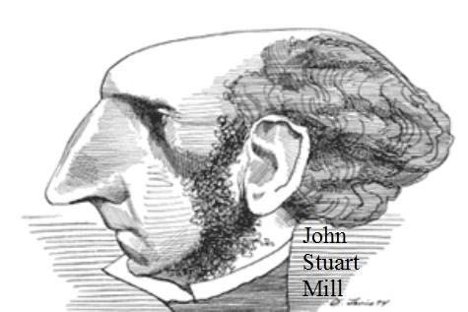
Mill was a British political economist, political philosopher, and a prolific classical liberal who surely stands among the most read and influential thinkers in the history of liberalism. J. S. Mill was, since he was a very young, educated into what his father hoped to be the leading intellectual of the time who would continue to promote the utilitarian principles of Jeremy Bentham and his father, James Mill. As a moral philosopher, J. S. Mill continued this tradition. As a political economist, Mill continued the liberal maxims of individual freedom, freedom to trade and barter. He was one of the first feminist thinkers, and as a politician, he was a very early proponent of women’s right to vote. He also advocated for unions and co-operative economic organization. It is a less known fact that Mill was a strong proponent of the democratization of industry; he believed that “eventually”, the economy will be organized wholly on co-operative principles. Probably Mill's most famous passages about worker ownership are from his Principles of Political Economy in the Chapter entitled "On the Probable Futurity of the Labouring Classes."
But if public spirit, generous sentiments, or true justice and equality are desired, association, not isolation, of interests, is the school in which these excellences are nurtured. The aim of improvement should be not solely to 3 place human beings in a condition in which they will be able to do without one another, but to enable them to work with or for one another in relations not involving dependence. ... But the civilizing and improving influences of association, ..., may be obtained without dividing the producers into two parties with hostile interests and feelings, the many who do the work being mere servants under the command of the one who supplies the funds, and having no interest of their own in the enterprise except to earn their wages with as little labor as possible. ... The form of association, however, which if mankind continue to improve, must be expected in the end to predominate, is not that which can exist between a capitalist as chief, and workpeople without a voice in the management, but the association of the labourers themselves on terms of equality, collectively owning the capital with which they carry on their operations, and working under managers elected and removable by themselves. ... It is scarcely possible to rate too highly this material benefit, which yet is as nothing compared with the moral revolution in society that would accompany it: the healing of the standing feud between capital and labour; the transformation of human life, from a conflict of classes struggling for opposite interests, to a friendly rivalry in the pursuit of a good common to all; the elevation of the dignity of labour; a new sense of security and independence in the labouring class; and the conversion of each human being's daily occupation into a school of the social sympathies and the practical intelligence. [Mill, John Stuart. 1848. Principles of Political Economy, Book IV, Chapter VII]
Eventually, and in perhaps a less remote future than may be supposed, we may, through the co-operative principle, see our way to a change in society, which would combine the freedom and independence of the individual, with the moral, intellectual, and economical advantages of aggregate production; and which, without violence or spoliation, or even any sudden disturbance of existing habits and expectations, would realize, at least in the industrial department, the best aspirations of the democratic spirit, by putting an end to the division of society into the industrious and the idle, and effacing all social distinctions but those fairly earned by personal services and exertions. Associations like those which we have described, by the very process of their success, are a course of education in those moral and active qualities by which alone success can be either deserved or attained. As associations multiplied, they would tend more and more to absorb all work-people, except those who have too little understanding, or too little virtue, to be capable of learning to act on any other system than that of narrow selfishness. As this change proceeded, owners of capital would gradually find it to their advantage, instead of maintaining the struggle of the old system with work-people of only the worst description, to lend their capital to the associations; to do this at a diminishing rate of interest, and at last, perhaps, even to exchange their capital for terminable annuities. In this or some such mode, the existing accumulations of capital might honestly, and by a kind of spontaneous process, become in the end the joint property of all who participate in their productive employment: a transformation which, thus effected, (and assuming of course that both sexes participate equally in the rights and in the government of the association)* would be the nearest approach to social justice, and the most beneficial ordering of industrial affairs for the universal good, which it is possible at present to foresee. [Ibid. pp. 793-4]
Many have tried to downplay Mill's views here by claiming that he was only accommodating the views of Harriett Taylor (his future wife). But Mill expressed similar views (somewhat less expansively) in his chapter on partnership and in an earlier 1845 essay "The Claims of Labour" (neither of which showed any influence from Taylor).
Finally, I must repeat my conviction, that the industrial economy which divides society absolutely into two portions, the payers of wages and the receivers of them, the first counted by thousands and the last by millions, in neither fit for, nor capable of, indefinite duration: and the possibility of changing this system from one of combination without dependence, and unity of interest instead of organized hostility, depends altogether upon the future developments of the Partnership principle. [Mill, John Stuart. 1848. Principles of Political Economy, 4 Book V, Chapter IX, sec. 5]
If, on a subject on which almost every thinker has his Utopia, we might be permitted to have ours; if we might point to the principle on which, at some distant date, we place our chief hope for healing the widening breach between those who toil and those who live on the produce of former toil; it would be that of raising the labourer from a receiver of hire--a mere bought instrument in the work of production, having no residuary interest in the work itself--to the position of being, in some sort, a partner in it. [Mill, John Stuart. 1967. “The Claims of Labour.” In Essays on Economics and Society; Collected Works Vol. IV, 363–89. Toronto: University of Toronto Press]

Senator Leland Stanford (1824-1893)
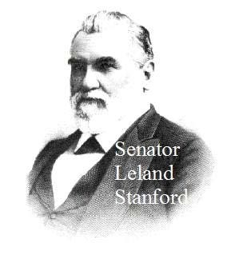
Senator Stanford was an American industrialist, politician, and social reformer. Together with his wife, Jane Stanford, they were founders of Stanford university. Leland Stanford was, for a short time, a practicing lawyer, but soon left the practice and moved to California and later to Sacramento where he and his wife started their railroad business. Despite his progressive views on the organization of industrial relations, he was accused of being a robber baron (using unscrupulous methods to get rich) and held quite openly racist views against the Chinese settlers. Politically, Stanford was a Republican and at one point become a leading member of the Republican Party. As a chairman of the U.S. Senate Committee on Public Buildings and Grounds, he authored a Senate bill to promote the creation of worker co-operatives. Stanford nurtured the ideas of employee ownership for many decades; he introduced them in his plans for Stanford University, in the beforementioned bill, and in numerous interviews. The following quotes from Stanford are all from the definitive article: Altenberg, L. (1990) ‘Beyond Capitalism: Leland Stanford’s Forgotten Vision’, Sandstone and Tile (Stanford Historical Society), 14 (1 Winter), pp. 8–20, which can be accessed at: http://dynamics.org/Altenberg/PAPERS/BCLSFV/BCLSFV_refs.html#Stanford
Labor can and will become its own employer through co-operative association.
The great advantage to labor arising out of co-operative effort has been apparent to me for many years. From my earliest acquaintance with the science of political economy, it has been evident to my mind that capital was the product of labor, and that therefore, in its best analysis there could be no natural conflict between capital and labor, ... between effort and the result of effort ... . Keeping this fundamental principle in view, it is obvious that the seeming antagonism between capital and labor is the result of deceptive appearance. I have always been fully persuaded that, through co-operation, labor could become its own employer.
In a condition of society and under an industrial organization which places labor completely at the mercy of capital, the accumulations of capital will necessarily be rapid, and an unequal distribution of wealth is at once to 5 be observed. This tendency would be carried to the utmost extreme, until eventually the largest accumulations of capital would not only subordinate labor but would override smaller aggregations.
The one remedy for this tendency, which to all appearances has been ineradicable from the industrial system, is the cooperation and intelligent direction of labor.
What I believe is, the time has come when the laboring men can perform for themselves the office of becoming their own employers; that the employer class is less indispensable in the modern organization of industries because the laboring men themselves possess sufficient intelligence to organize into co-operative relation and enjoy the entire benefits of their own labor.
With a greater intelligence, and with a better understanding of the principles of cooperation, the adoption of them in practice will, in time I imagine, cause most of the industries of the country to be carried on by these cooperative associations.
To comprehend it in all its breadth, however, let us assume that in all time all labor had been thus self-directing. If instead of the proposition before us to change the industrial system from the employed relation and place it under self-direction, the co-operative form of industrial organization had existed from all time, and we were now for the first time proposing to reorganize the employment of labor, and place it under non-concurrent direction, I apprehend the proposer of such a change would be regarded in the light of an enslaver of his race. He would be amenable to the charge that his effort was in the direction of reducing the laboring man to an automaton, and ... would leave but small distinction in the minds of workingmen between the submission of all labor to the uncontrolled direction of an employer, and actual slavery. We may safely assume that such a change would be impossible—that men are not likely to voluntarily surrender the independence of character which co-operation would establish for any lower degree of servitude ... . In fact co-operation is merely an extension to the industrial life of our people of our great political system of selfgovernment. That government itself is founded upon the great doctrine of the consent of the governed, and has its corner stone in the memorable principle that men are endowed with inalienable rights. This great principle has a clearly defined place in cooperative organization. The right of each individual in any relation to secure to himself the full benefits of his intelligence, his capacity, his industry and skill are among the inalienable inheritances of humanity.
For more on Stanford and worker cooperation, see the Altenberg article. Stanford was quite explicit about wanting to incorporate his goals in the founding of Stanford University:
We have then the three great leading objects of the university:
• first, education, with the object of enhancing the productive capacity of men equally with their intellectual culture;
• second, the conservation of the great doctrines of inalienable right in the citizen as the cornerstone of just government;
• third, the independence of capital and the self-employment of non-capitalist classes, by such system of instruction as will tend to the establishment of cooperative effort in the industrial systems of the future.
And according to Altenburg, Stanford placed in the Grant of Endowment the clause that the Trustees "shall have the power, and it shall be their duty ... To have taught in the University the right and advantages of association and co-operation."
Coincidentally or not, there is one Professor of Economics at Stanford, John Pencavel, who writes on worker cooperatives, and who, to my knowledge, is the only such professor at a major American university. Two of his books are: Pencavel, John (2001) Worker Participation: Lessons from the Worker Co-ops of the Pacific Northwest. New York: Russell Sage Foundation, and Pencavel, John, ed. 2013. The Economics of Worker Cooperatives. Aldershot UK: Edward Elgar Publishing.

Henry Carter Adams (1851-1921)
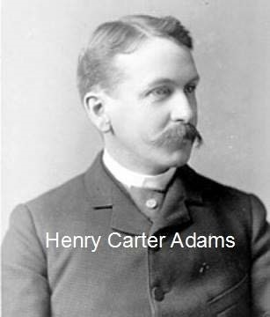
Adams was a U.S. economist and Professor of Political Economy and Finance at the University of Michigan. He later became head of the newly created Economics Department at Michigan, however he always understood economics within the context of political economy, not reduced to the study of data and statistics. He occupied himself with labor and working-class questions. While previously at Cornell, he delivered an addressed titled “The Labor Problem” where he expressed support to the Great Southwest railroad strike of 1886. Later on, Henry Sage, a benefactor and trustee of Cornell University at the time, wanted Adams fired saying that “he is sapping the foundations of our society” . Indeed, human rentals were and remain the foundations of our society, however this by itself does not justify it; Adams, like many others, have recognized certain injustices of this institution and worked to subvert it. Adams was a friend of John Dewey and while teaching at Cornell University was "relieved" of his duties as a result of a crusade by Cornell trustee Russell Sage (who set up the foundation named after himself) following the publication of the article quoted here. For that story, see Westbrook, Robert. 1991. John Dewey and American Democracy. Ithaca: Cornell University Press.
The practical plan through which that liberty promised by democracy is to be realized, is the abandonment of the wages system and the establishment of industries upon the cooperative basis. It is then the realization of cooperative economy which is to serve as the ideal of democratic peoples. If this appears disappointing in any way, and inadequate to the great task assigned it, the source of disappointment is that you do not understand cooperation, and do not perceive what an influence it will have in modifying character and changing the purposes for which men work. A society based upon cooperative industry is as different in itself and in its tendencies, from a society based upon wages industry, as the latter is from a society based upon slavery. Thus cooperation is a further step in the direct line of development which carried civilization from a state of slavery to freedom. [Adams, Henry Carter. 1881. “Democracy.” New Englander IV (6): 752–72, pp. 771-2]

Henry Wickham Steed (1871-1956)
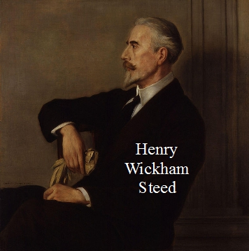
Steed was an English journalist and a historian by profession, and he held the position of the editor of The Times. In his early years, Steed visited universities of Jena, Berlin, and Paris, and showed an interest in the issue of social democracy. During his time in continental Europe, Steed met certain important figures from the left like Friedrich Engels, Wilhelm Liebknecht, August Bebel, and Alexandre Millerand. The encounters inspired his first book The Socialist and Labour Movement in England, Germany & France (1894). Steed was interested in more liberal and social democrat attitudes towards economic reforms than in the socialist tradition of his day. He tried to get the Conservative Party to adopt a form of Employee Partnership (with capital-suppliers) that he described in his book: The Real Stanley Baldwin. London: Nisbet & Co., 1930. Steed gave an extensive description of a New Zealand co-partnership law that was also mentioned by Robert S. Brookings in his last book, The Way Forward (see below on Brookings). Here is an excerpt from Steed's book on the NZ law.
In 1924 some business men in New Zealand, convinced that our economic system was cracking, crumbling and tottering, and that, unless something drastic and far-reaching were done, it would crash to the ground, dragging with it in its fall the whole structure of Western civilisation, persuaded the New Zealand Parliament to pass a "Companies Empowering Act" to establish the principle of limiting payment for the services of capital, and to authorise the issue by industrial companies of "Labour shares" on a footing of equality with their "Capital shares." The idea was that, normally, in company organisation there are three classes to be considered:
(1) The Contributors of Property-those who take no active part in the conduct of the business and contribute capital only;
(2) The Contributors of Service-those who make no capital contribution, and contribute service only ;
(3) The Contributors of both Service and Property those who possess a dual status in virtue of their dual contributions.
But, in the attempt to give legal effect to these ideas, it was found that the laws of New Zealand made it impossible to confer upon holders of Labour, or "Service," shares a legal status in virtue of their contribution of Service, qua service, since the Companies Act did not recognise service as a qualification for membership in a company. Therefore an amendment to the Companies Act was brought in and passed under the title "Companies Empowering Act, 1924," which gave a legal standing to the holders of Labour shares. Thus it became possible for companies to issue (1) Capital shares entitling the holders to receive a fixed remuneration based on the current market values of money and, in addition to this, a risk rate proportionate to the character of the enterprise; and (2) Labour shares which all contributors of Service, from the managing director to the office boy, should be qualified to receive and to hold (but not to sell) in proportion to the degree of service rendered.
These Labour shares were to be, and have been, issued as a free gift to the employees of companies. They were not given in return for payment, but in recognition of an ethical right. The principle of limiting payment for capital was based on the fact that by far the larger portion of capital now invested in business is paid for at limited rates of interest, namely mortgages, preference shares, debentures, loans and overdrafts. By limiting, from the outset, the remuneration of Capital and by endowing Labour with special remuneration in return for its service, it was found that a subtle transformation had been effected in the outlook of workmen and employees generally. The human element was placed first, and the human instinct for justice was satisfied by allowing extra payment, in the form of earned dividends, to be made for service in accordance with results. Personal incentive was brought into play, for every worker became directly interested in the success of the enterprise by being made a genuine partner. His interest extended beyond a mere share in profits, since Labour shareholders were entitled to elect their representatives to the board of directors and to have a voice in control similar to that of Capital shareholders. The result was that the contributors of service became increasingly educated in the control of industry-a factor essential to any permanent solution of the industrial problem.
More important still, suspicion and ill-feeling between Capital and Labour vanished. Knowing exactly what was being done and why, workmen set their faces against "slacking " or inefficiency among their fellows. They suggested and carried through economies which no managing director could have secured from unwilling men. Despite the higher remuneration they received, they contrived to cheapen, by zealous work, the cost of production. Mutual respect grew up between Capital directors and Labour directors, since all found that they were working for the good of the Company in which all were partners.
This system, of which the indispensable feature is the placing of a limit on the remuneration of all capital, has been successfully applied to coal mining, to saw mills and, at least, to one printing and newspaper enterprise. The rates of interest on capital have ranged from 5 per cent., plus a risk rate of 3 per cent. in coal mining, to 7 per cent., plus 2 per cent. in the printing and newspaper business. In order to promote the application of this system "The Employee Partnership Institute " has been founded at Hamilton, New Zealand ; but inasmuch as practical results are more valuable than precepts in social reform, the case of the "Waikato and King Country Press Limited" of Hamilton deserves special attention. … [pp. 169-171]

Robert S. Brookings (1850-1932)
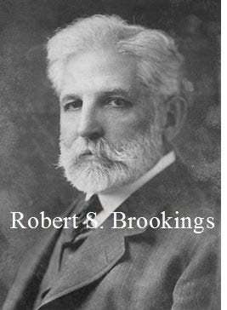
Brookings was born and acquired his early education in Cecil County, Maryland. But he dropped out of school and later moved to Missouri to work. Brookings found to be gifted in business conduct so he rapidly advanced to become a salesperson and soon after the partner and the vice-president of Cupples & Marston. He traveled around Europe, gaining on perspective and social understanding. When Brookings eventually returned to the States, he pursued and attained a very successful business career. He was a civil leader and a philanthropist, renowned for his involvement with building Washington University and for founding The Brookings Institution. With age, Brookings got increasingly interested in social reform. He authored three books: Industrial Ownership (1925), Economic Democracy (1929), and The Way Forward (1932). In his last book, The Way Forward, Brookings made the following proposals. A few years ago, a friend (of the first author) who then worked at the Brookings Institution walked around the hallways reading these quotes to staffers and asked who they thought was the author. Usually, the answer was: "Karl Marx."
The corporation has with us demonstrated itself as the most efficient organization for the production, distribution, and division of wealth, and, as practically all of our corporations are conducting either an interstate or international business, under our constitution it would seem that Congress has the power to require that such corporations should reincorporate under a federal incorporation act; which act, while securing to capital a fair return at a fixed rate of interest and dividends, risk considered, would divide all additional profit or accretions in the form of labor shares between the employees (management and labor) in the ratio of their individual contribution, probably as recorded by their wage or salary compensation. [Brookings, Robert S. 1932. The Way Forward. New York: MacMillan, pp. 17-18]
This reform would consist largely in the rental of capital by the workers and management, stabilizing a fair rental return for it while leaving the workers and management as their remuneration all the profits. [Ibid., pp. 73- 74]
As the whole profit and loss in industry would, under this act, accrue to labor and management, they would naturally devise ways and means to take care of their own unemployment problems, whether by reducing days and hours of operation, or by some other process. [Ibid., p. 23]

Lord Eustace Percy (1887-1958)
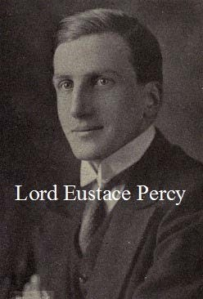
Lord Percy was born in an aristocratic family to Duke of Northumberland and Lady Edith. Percy received elite education at Eton and Christ Church, Oxford. He was a British diplomat, a Conservative politician, and a public servant. Percy long served in the Diplomatic Service and was later appointed as President of the Board of Education. Because of his supposed influence as a member of the Conservative cabinet, he was often dubbed as the “Minister of Thought” by the press. His most relevant publication for present purposes is: Percy, Eustace. 1944. The Unknown State: 16th Riddell Memorial Lectures. London: Oxford University Press. In these 1944 Riddell Lectures, he gave a remarkable and radical call for the reconstituting of the standard limited liability company; limited liability companies should not be considered as associations of shareholders who owned or rented productive assets. Rather, companies should be recognized as associations of people working there.
The example I wish to give is peculiarly controversial; but I cannot shirk it, for the whole future of modern civilization seems to me to turn upon it. My example is the limited liability company, on which the livelihood of the modern citizen and the solvency of the modern State principally depend.
To the historian unlearned in the law, the industrial company of the nineteenth and twentieth centuries is the direct successor, by natural evolution, of the joint trading ventures of earlier days; the modern shareholder is the immediate descendant (let us say) of the 'proprietors' of the East India Company. That, too, is the common assumption of the trade unionist and of the general public; it is the assumption also of the director, who talks easily of 'the property of our shareholders'. But in law this view is wrong. Legally, a 'company' at any given moment is a board of directors, acting within the limits of Articles of Association. The shareholder is, not a partner, but a simple creditor; he has an 'equitable interest' in the company's transactions, but he has no insurable interest in its property. [break 36 to 37] On a winding-up, he can claim his share in the break-up value of the company's assets, but he invests his money on the assumption that the company will be wound up only when its assets are relatively valueless.
Yet, in order (presumably) that he may protect his equitable interest, this irresponsible creditor elects the directors. He neither is the company (even if he is the sole shareholder) nor owns the company, but he constitutes the company. This constituent power is seldom effective and its exercise cannot usually be more than a formality ; but it invests the shareholder with the same sort of responsibility as that of a parliamentary elector. Indeed, this whole branch of the law is obscurely biased by the political analogies of the mid-nineteenth century. The director is elected, because that is constitutional good form. When elected, he is responsible to the shareholders, as a Victorian Member of Parliament was responsible to his tax paying constituents. But his responsibility is for general honesty and due economy, with 'redress of grievances' affecting the personal interests of his constituents. He is not responsible to them for the conditions of employment of hundreds or thousands of workmen, any more than the Victorian M.P. was responsible to his constituents for the internal administration by the Crown of the Queen 's Army and Navy. When 'enlightened self-interest ' was thought the best guide to policy, such a division of responsibilities was natural ; but today, when it has been superseded in politics by the principle that the interest and responsibility of both M.P. and elector extend over the whole field of government, its persistence in industry is neither understood nor trusted. If it is still understood and trusted more in the United States than in this country, the explanation may lie partly in the division of responsibilities still recognized in government by the American Constitution.
Yet, in face of this misunderstanding and distrust, the jurist, busy on the reform of company law, continues to conceive such reform almost exclusively in terms of protecting the financial interest of the shareholder against misrepresentation and maladministration. I believe that much of the current talk about the 'profit motive' is untrue to facts and dangerous to morals, because it transfers to a single scapegoat the love of money which is the sin of all men . But the trouble is that such [break 37 to 38] talk is not the invention of sentimental propagandists, but the cold assertion of the law. Current profit (as opposed even to the prudent administration of property) is the only interest which the law recognizes in the shareholder. The legislator, therefore, tends increasingly to assume that it must be the predominant interest also of the director whom the shareholder elects. Reasoning thus, the legislator drifts into absurdity in his administrative statutes and is forced into something worse than absurdity in his statutes of high policy. He places responsibility for observance of safety regulations in mines, not upon the company, but personally upon the colliery manager who is the company's servant ; and he balances his denial of the shareholders' responsibility for anything but their own financial interests by absolving the workmen from any responsibility for respecting those interests. It is not trade union law alone which has reintroduced ordeal by battle as the normal method of regulating personal relationships in industry; it is company law itself which has disabled the State from offering any other legal remedy to the employer or to the employed.
The following paragraph is the crucial one that is often quoted as in: Goyder, George. 1961. The Responsible Company. Oxford: Basil Blackwell, 57.
Here is the most urgent challenge to political invention ever offered to the jurist and the statesman. The human association which in fact produces and distributes wealth, the association of workmen, managers, technicians and directors, is not an association recognized by the law. The association which the law does recognize, the association of shareholder-creditors and directors, is incapable of production or distribution and is not expected by the law to perform those functions. We have to give law to the real association, and to withdraw meaningless privilege from the imaginary one.
Then Percy continues his analysis using the dubious idea that the management of a company is the management of property, not of the people working in the company.
But the statesman shows little sign of fitness for this task, mainly, perhaps, because he still tends to be misled by the political analogy. If he is alive to the problem at all, he thinks of it in terms of 'industrial democracy', of giving to the workman voting rights similar to those now possessed by the shareholder. The analogy is false, for there is no similarity between the management of a property and the government of a State. And, even if the analogy were true, it would point in almost the opposite direction. In English theory and practice, at least, parliamentary democracy does not consist in the direct election of an executive; and continental [break p.38 to 39] experience indicates that a democracy which tries so to constitute its executive destroys itself. So the positivist, seeking to fit law to the cold facts, must turn for clarification and definition from the compromises of statesmanship to the logic of the jurist. Having said that, I must not myself presume to suggest remedies, but it is not, I suppose, difficult to guess in what general direction they lie. 'Trust' was the most respectable word in the language of the law until it was applied to certain industrial combinations; it may prove in the future to be the most powerful word in that language if it is now applied to the whole field of industrial association. The jurist shrinks from the diminution or transfer of property rights, even to fit changed facts ; but he will readily modify, in such circumstances, the purposes of a trust. And in this field, such modification can be effected without real injustice. An unlimited trust for the benefit of the actual members of an industrial unit, whose livelihood depends upon its prosperity, subject only to a redefined liability to its creditors, limited to fair interest and sinking fund on their loan, will deprive those creditors of no expectation on which, in these days of economic revolution, they can reasonably rely. The difficulty lies, of course, in the method by which such a trust is to be constituted and perpetuated, not merely for existing corporations but for the new enterprises of the future, without conferring upon a State bureaucracy a dangerous power to resist novelty and restrict freedom. On that problem I will only say that there is always a price to be paid for facing facts, but it is smaller than the cost of contentment with fictions. [pp. 36-39]

Sir Alfred Eckhard Zimmern (1879–1957)

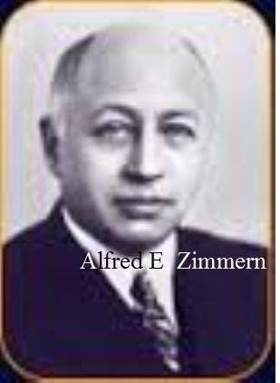
Sir Alfred Zimmern was born in Surbiton, UK. He was brought up as a Christian but later become a supporter of Zionism. Zimmerman was an English classical scholar, political scientist, and a historian. His book The Third British Empire was among the first to apply the expression "British Commonwealth" to the British Empire. Zimmerman was also credited with the phrase “welfare state”. He pursued an academic career, starting as a lecturer at New College, Oxford in 1903, later came to be a Fellow and a tutor, and finally became a Professor of International Relations. Zimmerman co-founded the Royal Institute for International Affairs in 1919. When it came to international relations, he was often designated as utopian and idealist, and contributed to founding of the League of Nations Society and of UNESCO. Zimmerman shortly entered politics with the Labour Party in 1924. His book Nationality and Government (London: Chatto & Windus, 1918), contains a call for democracy in the workplace. Here are some of the relevant passages.
Both industry and politics are faced by what in politics is called the constitutional problem and in industry the problem of management--that is, the question of who is to be ultimately responsible for the conduct of the work and how that responsibility is to be exercised. In politics, so far as this and most Western countries are concerned, this problem of management has been decided in favour of democracy. The people as a whole have taken into their hands the ultimate responsibility for the conduct of public business, and entrust its direction to Ministers or servants who are responsible to the people for their acts and policy. In industry, however, the problem of management is still unsolved, or rather it has hitherto been decided in a direction adverse to democracy. The manager in industry is not like the Minister in politics : he is not chosen by or responsible to the workers in the industry but chosen by and responsible to partners or directors some other autocratic authority. Instead of the manager being the Minister or servant and the men the ultimate masters the men are the servants and the manager and the external power behind him the master. Thus, while our governmental organisation is democratic in theory, and by the extension of education is continually becoming more so in practice, our industrial organisation is built upon a different basis. It is an autocracy, but not an untempered autocracy. It may perhaps be described as 13 autocracy modified by Trade Union criticism and interference and by Parliamentary and administrative control. [pp. 262-263] ...
But the contrast between political democracy and industrial autocracy--between the workman as a free citizen and the workman as a wage-earner--is so glaring that it has become obvious that it cannot indefinitely continue in its present form. Men who have tasted what freedom and responsibility mean in one department of life are not likely to acquiesce in remaining mere irresponsible instruments of production in the industrial sphere. [p. 263]
Our policy must be, not to make output mechanically perfect by turning the workman himself into a mere machine, but to make our organisation scientific in the widest sense by the voluntary and harmonious cooperation of all the human factors concerned. It is along this road, and no other, that we shall reach the industrial democracy of the future, towards which the English industrial idealists of the nineteenth century-Ruskin, William Morris, and John Stuart Mill-were bold enough to point the way. [pp. 265-6]
Essentially the same passages occur in an earlier book: Zimmern, Alfred E. 1916. “The Control of Industry After the War.” In The Reorganization of Industry, 61–85. Oxford: Ruskin College.

Alfred Marshall (1842-1924)
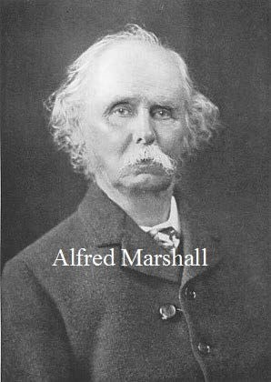
Marshall was one of the most influential economists of late 19th and early 20th century, known for his pioneering work on the neoclassical economics. His book, Principles of Economics from 1890 was the dominant Economics textbook for many years. Marshall was interested in reform of capitalism and was focused on the social change, rather than on the ultimate end-state as such. He saw the process of transformation as gradual, democratic, and peaceful. Marshall was the president of the 1889 Cooperative Congress and a significant supporter of the Cooperative Movement. His work dealt with cooperative ethics, cooperative organization, and constructive cooperation. Below are some of his comments on worker cooperatives in his Principles book.
§ 10. The system of co-operation aims at avoiding the evils of these two methods of business management. In that ideal form of co-operative society, for which many still fondly hope, but which as yet has been scantily realized in practice, a part or the whole of those shareholders who undertake the risks of the business are themselves employed by it. The employees, whether they contribute towards the material capital of the business or not, have a share in its profits, and some power of voting at the general meetings at which the broad lines of its policy are laid down, and the officers appointed who are to carry that policy into effect. They are thus the employers and masters of their own managers and foremen; they have fairly good means of judging whether the higher work of engineering the business is conducted honestly and efficiently, and they have the best possible opportunities for detecting any laxity or incompetence in its detailed administration. And lastly they render unnecessary some of the minor work of superintendence that is required in other establishments; for their own pecuniary interests and the pride they take in the success of their own business make each of them averse to any shirking of work either by himself or by his fellow-workmen. [Marshall, Alfred. 1961. Principles of Economics. London: MacMillan and Company. p. 305]

John Dewey (1859-1952)
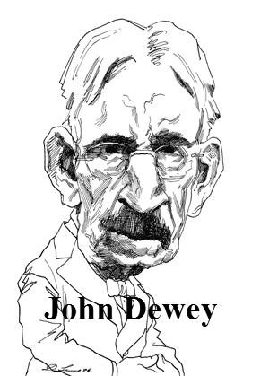
Dewey was born in Burlington, Vermont to a family of modest means. He received his Ph.D. at John Hopkins University in 1884. Today, he is considered as one of the more influential philosophers of 20th century, a pioneer of pragmatist school of philosophy, and a leader of the progressive movement in education in the US. Dewey spent the majority of his career at Columbia University in New York City where he wrote his most famous philosophical works.
The common theme underlying Dewey’s philosophical and political work was his strong belief that democratic society of informed and engaged inquirers was the best arrangement of promoting human well-being and interest. Dewey saw democracy as an active process of social planning, a collective action in different spheres of social life, but also as a source of morality, values, and beliefs that provide guidance for the evolution of social institutions. Dewey himself stated in 1888, while still at the University of Michigan, “Democracy and the one, ultimate, ethical ideal of humanity are to my mind synonymous." In a democratic end state, people would treat each other with respect and there would be high levels of cooperation. One of the modern institutions that democracy did not yet manage to penetrate is an economic enterprise, Dewey claimed. There are many quotes from Dewey's works about industrial democracy and cooperative production. Here are a few.
It is the work of sociologists, psychologists, novelists, dramatists and poets to exhibit the consequences of our present economic regime upon taste, desire, satisfaction and standards of value. An article like this cannot do a work which requires many volumes. But a paragraph suffices to call attention to one central fact. Most of those who are engaged in the outward work of production and distribution of economic commodities have no share-- imaginative, intellectual, emotional--in directing the activities in which they physically participate.
It was remarked in an earlier chapter that there is definite restriction placed upon existing corporateness. It is found in the fact that economic associations are fixed in ways which exclude most of the workers in them from taking part in their management. The subordination of the enterprises to pecuniary profit reacts to make the workers 'hands' only. Their hearts and brains are not engaged. They execute plans which they do not form, and of whose meaning and intent they are ignorant-beyond the fact that these plans make a profit for others and secure a wage for themselves. To set forth the consequences of this fact upon the experience and the minds of uncounted multitudes would again require volumes. But there is an undeniable limitation of opportunities, and minds are warped, frustrated, unnourished by their activities--the ultimate source of all constant nurture of the spirit. The philosopher's idea of a complete separation of mind and body is realized in thousands of industrial workers, and the result is a depressed body and an empty and distorted mind.
There are instances, here and there, of the intellectual and moral effects which accrue when workers can employ their feelings and imaginations as well as their muscles in what they do. But it is still impossible to foresee in detail what would happen if a system of cooperative control of industry were generally substituted for the present system of exclusion. There would be an enormous liberation of mind, and the mind thus set free would have constant direction and nourishment. Desire for related knowledge, physical and social, would be created and rewarded; initiative and responsibility would be demanded and achieved. One may not, perhaps, be entitled to predict that an efflorescence of a distinctive social culture would immediately result. But one can say without hesitation that we shall attain only the personal cultivation of a class, and not a characteristic American culture, unless this condition is fulfilled. It is impossible for a highly industrialized society to attain a widespread high excellence of mind when multitudes are excluded from occasion for the use of thought and emotion in their daily occupations. The contradiction is so great and so pervasive that a favorable issue is hopeless. We must wrest our general culture from an industrialized civilization; and this fact signifies that industry must itself become a primary educative and cultural force for those engaged in it." [Dewey, John. 1962 (1930). Individualism Old and New. New York: Capricorn Books, pp. 131-33]
This passage should be compared to passage from John Stuart Mill about the effects that workplace democracy could have on people.
In Reconstruction in Philosophy, Dewey argued that democracy
is but a name for the fact that human nature is developed only when its elements take part in directing things which are common, things for the sake of which man and women form groups-families, industrial companies, governments, churches, scientific associations and so on. The principle holds as much of one form of association, say in industry and commerce, as it does in government [Dewey, John. 1948. Reconstruction in Philosophy (Enlarged Edition). Boston: Beacon Press, 209].
After World War II, Dewey repeated what he said about social reorganization after World War I:
It is so common to point out the absurdity of conducting a war for political democracy which leaves industrial and economic autocracy practically untouched, that I think we are absolutely bound to see, after the war, either a period of very great unrest, . . . or a movement to install the principle of self-government within industries [Dewey in: Ratner, Joseph. 1939. Intelligence in the Modern World: John Dewey’s Philosophy. New York: Modern Library, 422].
For illustration, I do not need to do more than point to the moral, emotional and intellectual effect upon both employers and laborers of the existing industrial system. . . . I suppose that every one who reflects upon the subject admits that it is impossible that the ways in which activities are carried on for the greater part of the 16 waking hours of the day, and the way in which the share of individuals are involved in the management of affairs in such a matter as gaining a livelihood and attaining material and social security, can not but be a highly important factor in shaping personal dispositions; in short, forming character and intelligence. [Dewey in: Ratner, Joseph. 1939. Intelligence in the Modern World: John Dewey’s Philosophy. New York: Modern Library, 716-17]
While "democratic social organization make[s] provision for this direct participation in control: in the economic region, control remains external and autocratic" [Dewey, John. 1916. Democracy and Education. New York: Free Press, 260]
Control of industry is from the top downwards, not from the bottom upwards. The greater number of persons engaged in shops and factories are 'subordinates.' They are used to receiving orders from their superiors and acting as passive organs of transmission and execution. They have no active part in making plans or forming policies-the function comparable to the legislative in government-nor in adjudicating disputes which arise. In short their mental habits are unfit for accepting the intellectual responsibilities involved in political self-government. [Dewey, John, and James Tufts. 1932. Ethics. New York: Henry Holt, 393-92]

Paul Douglas (1892-1976)
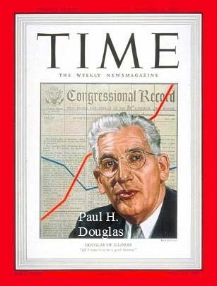
Senator Paul Douglas was born in Salem, Massachusetts. He attained a Ph.D. in Economics at Columbia University and went on to pursue a career of the politician and an economist. Douglas is considered to be a Georgist economist with the focus on industrial relations, the topic he taught at Chicago University (he, however, never was part of the so-called “Chicago School of Economics”). He is probably best known for being the "Douglas" in the Cobb-Douglas production function. Later he became involved with the politics and was registered as Independent, because he thought the Democratic Party was too corrupt while the Republican Party too reactionary. Douglas served on the Consumers’ Advisory Board of the National Recovery Administration under President Franklin D. Roosevelt. In 1926, he published a book that was a case study of an experiment in industrial democracy in an Indianapolis canning company. At the beginning of the last chapter, he summarized the results.
The eight years' experience with this sincere and engrossing experiment conducted upon so fundamentally different a basis from that of industry as a whole has been most heartening to all who wish for a better social order. The workers have proved themselves increasingly capable of wise and efficient government and of whole-souled co-operation in working for the best interests of the concern. In practically every case when an issue has arisen between their immediate self-interest and the welfare of the company, they have adopted the altruistic course with little hesitation. The business has stood the stress and strain of the feverish years of prosperity and depression, and its efficiency is higher today than it was at the inception of the plan. [Douglas, Paul H. 1926. The Columbia Conserve Company: A Unique Experiment in Industrial Democracy. Chicago: University of Chicago Press, p. 53]

Arthur Cecil Pigou (1877-1959)
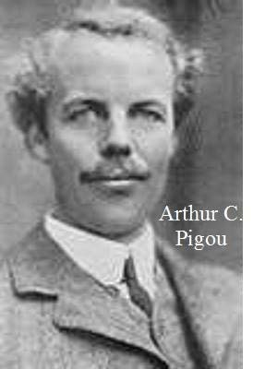
A. C. Pigou was born at Ryde on the Isle of Wight. He enjoyed a successful academic career which started when he was a young adult, studying under Alfred Marshall. Pigou started teaching economics in 1901 and became a Fellow of King’s College in 1902, later on he was elected as the President of Political Economy at Cambridge University in 1908. Today, Pigou Club consists of modern economists and environmental experts supporting ideas like carbon tax to tackle the problem of climate change. Pigou also studied labor markets, for example he emphasized the negative role of sticky wages in recession recovery. Pigou’s main contribution to economics were in his book The Economics of Welfare (1920), where he introduced the notion of an externality and proposed a solution with what is known today as Pigovian tax. In this book, he also discussed the necessary changes in industrial organization.
It is more and more coming to be recognised that, if one root of “labour unrest” has been dissatisfaction with rates of wages, a second root, also of great importance, has been dissatisfaction with the general status of wage labor— the feeling that the industrial system, as it is to-day, deprives the workpeople of the liberties and responsibilities proper to free men, and renders them mere tools to be used or dispensed with at the convenience of others: the sense, in short, as Mazzini put it long ago, that capital is the despot of labour. Changes in industrial organisation that tend to give greater control over their own lives to workpeople, whether through workmen's councils to overlook matters of discipline and workshop organisation in conjunction with the employer, or through a democratically elected Parliament directly responsible for nationalised industries, or, if this should prove feasible, through some form of State-recognised as a whole, and State-controlled national guilds, might increase welfare even though they were to leave unchanged, or actually to damage, economic welfare." [Pigou, Arthur C. 1960. The Economics of Welfare. (4th Ed.). London: Macmillan, pp. 16-17]
This train of thought suggests that, in a community organised on the general lines of a modern industrial State, associations of workers combined together in small co-partner-ship workshops constitute an industrial form, investment in which is likely to yield a marginal social net product considerably in excess of the marginal trade net product. For such workshops provide the first stage of the ladder that is needed to lift upwards the great fund of capacity for management that is almost certainly lying latent among the manual labouring classes. They furnish, as it were, a first school in which this capacity can be developed, and, in so doing, contribute for the service of the community, not merely boots and shoes, but well-trained, competent men. [Ibid., pp. 181-2]

Jacques Maritain (1882-1973)
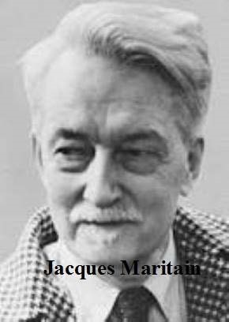
Jacques Maritain was a French philosopher, political thinker, and one of the principal modern scholars on Thomism and an interpreter of Thomas Aquinas. He was born and raised in Paris and was later struck by the spiritual aridity of French intellectuals at the time. Maritain's interest and works spanned many aspects of philosophy, including aesthetics, political theory, philosophy of science, metaphysics, the nature of education, liturgy, and ecclesiology. Maritain was a Christian philosopher, however his ideas and political philosophy had a liberal character, for which he was attacked by the right. His presence and influence in South America left him designated as the “man of the left” by the Chilean authorities in the 30s. He spent his academic career in numerous French and some American universities such as Notre Dame, Columbia, and Princeton University. His moral philosophy lays within Aristotelean-Thomistic natural law tradition and held that the law in human nature is derivative of some divine law. Maritain held that human natural rights are fundamental and inalienable, and should be superior to societal rules and institutions. His discussions on philosophy of law also led him to oppose the wage system and to argue for a system of associative joint ownership. Moreover, he distinguished between joint ownership as an "association of persons" as opposed to joint property ownership. In more recent terms, the people working in a cooperative firm are members as a personal right, not joint owners as a property right.
Aside from certain areas of altogether general interest, whose transformation into public services is to be expected, it is an associative system substituting, as far as possible, joint ownership for the wage system, that, in 19 such a conception and in what above all concerns the industrial level. ought to take the place of the capitalist regime. The working personnel would thus participate in the management of the undertaking, for which, from another point of view, modern technical progress allows the hope of a certain decentralization. When I speak of the associative form of industrial ownership, I am thinking of an association of persons (management-technicians, workers, investors) entirely different from the associations of capital which the idea of joint ownership might suggest under the present regime. [Maritain, Jacques. 1986. Christianity and Democracy, and The Rights of Man and Natural Law. Trans. Doris C. Anson. San Francisco: Ignatius Press, p. 175]
In his commentary on the employment relation of renting, hiring, or employing people, Maritain argued that the relationship should be changed to one of delegation (where those doing the directing were representatives of those governed working for their common good) instead of alienation. In the employment relation, those who are directed have alienated their self-governing rights as well as the fruits of their labor so they are functioning as the "organ of another person."
This right is not merely opposed to slavery in its strict sense, it also involves an aspiration or a wish opposed to servitude in its most general sense, that is to say, opposed to that form of authority of one man over another in which the one who is directed is not directed toward the common good by the official charged with this duty, but is at the service of the particular good of the one who is doing the directing, thus alienating his own activity and giving over to another the benefit (the fruit of his activity) which should rightly be his, in other words, becoming to that extent the organ of another person. [Ibid., p. 182]

George P. Brockway (1916–2001)
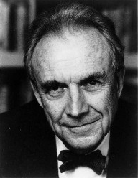
Brockway was born in Portland, received a Bachelor degree in 1936 from Williams College, and was later elected to Phi Beta Kappa. He was the president of the W. W. Norton & Company and a learned (non-academic) economist. Brockway created a special ownership structure that allowed W. W. Norton & Company to remain independent for 78 years, an age of maturity, which few publishing houses were able to reach without being bought out by larger corporate entities. Upon retirement, he focused solely on writing pieces about economics, regularly for The New Leader under the name The Dismal Science and was a founder of the Journal Post-Keynesian Economics. Brockway was a great defender of employee ownership, both in theory and practice.
As David Colander put it in his remembrance when referring to the time of Brockway's presidency in Norton:
It was during this time that he was instrumental in structuring Norton as a true employee-owned company in which all long-term employees must own shares of stock and must sell them back to the company when they leave. In my view that structure is the greatest monument to George’s insight and understanding of how the economic system works. It has kept Norton independent ever since, while almost all other publishing companies have become merged into large conglomerates. That corporate structure has allowed Norton much more freedom than other publishers, owned by big conglomerates, have. In creating that corporate structure George contributed enormously to creating new institutions that furthered progressive thought. It is that type of entrepreneurship that can change society. [Colander, David. 2002. “George Brockway: A Remembrance.” Journal of Post Keynesian Economics 24 (3): 499–502. https://doi.org/10.1080/01603477.2002.11490339. p. 502]
Brockway's theoretical vision of property in the Labor Theory of Right (usually called the labor theory of property) was quite remarkable and almost unique among economists.
Although it is impossible to imagine the easy success of any movement to reform the modem corporation, it is not difficult to suggest points that such reform might encompass. Starting with the understanding that the corporation is the entrepreneur and so entitled to the profits and the capital gains, one would ask, Who are the people of the corporation? And the answer would be that they are first and foremost those who do the work of the corporation, namely , the management and the other workers, and secondarily the stockholders, under the present system, and that they should all be able to share in both rewards and control.
As a first approximation of how these shares should be allocated, one might assume that there is some rationality behind the present distribution. At present, management and other workers get wages and bonuses and fringe benefits, and stock holders get dividends, and these are the more or less satisfactory result of explicit or implicit negotiations . Each individual's proper share might then be determined by taking the individual's income from the corporation, whether wages or dividends or both, and dividing it by the total of all individual incomes from the corporation (not counting interest, which is a cost of doing business) . Cash dividends would be paid in accordance with such shares, which would be recalculated annually. In addition to cash dividends-and it is a crucial addition-new stock equal in value the corporation's increase in net worth would be issued in the same proportions as cash dividends (or stock would be canceled if net worth fell). This stock--and sooner or later all stock in the corporation--would be inalienable. It could not be sold or bequeathed or pledged as security for a loan or given away; but it could at any time be exchanged with the corporation for a negotiable note or bond, or, at the corporation 's option, cash. And such an exchange would have to be made when the owner of the stock left the corporation, retired, was fired, or died. Over the years--within a generation at the outside--most of the present stockholders would be converted into bondholders. They would have their reward. The remaining stockholders would all be active in the business. They could, of course, like their predecessors, run it well or ill; could sell it or merge it or abandon it; but whatever happened, it would be their doing, and they would be the ones to benefit or suffer from it.
Let me state most emphatically that what I call the Labor Theory of Right leads to employee ownership, not to profit sharing. Profit is, as we have repeatedly noted, a residual. It is systematically unpredictable. It is, nevertheless, affected by decisions regarding everything from product development to marketing. The interests of laborers and owners in such decisions are rarely identical; sometimes they are diametrically opposed. In profit sharing, conflicts are resolved in favor of owners. When laborers and owners are the same people, decisions can turn on the interests of the enterprise rather than on class advantage. Decisions may still turn out to be right or wrong, but they will be so for everyone. There will be neither scapegoats nor windfall profiteers. [Brockway, George P. (1995) The End of Economic Man: Principles of Any Future Economics (3rd ed.). New York: W. W. Norton, pp. 302-3]
See also the chapter: "Property: The Labor Theory of Right" in the same book.

Owen D. Young (1874-1962)
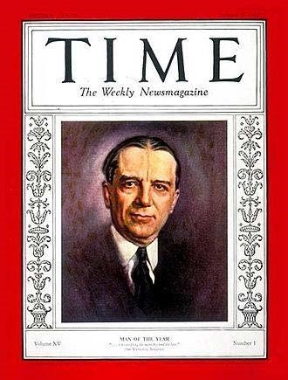
Young was an American industrialist, lawyer, and a diplomat. He was born on a small farm in the village of Van Hornesville, New York. While he was from a small farming family, he was always prone to learning and reading. His parents mortgaged the farm to send him to St. Lawrence University in Canton, where he studied law. In the very start of his career, he represented Stone and Webster against General Electric and came to the attention of the President of GE, Charles Coffin, who invited Young to become the company’s Chief Counsel in 1912. In ten years, he became the President of GE and later the founder of the Radio Corporation of America (RCA). In his public service, h became the counsel to the President Woodrow Wilson, co-authored the Dawes Plan, and later the Young Plan which dealt with the German reparations following WWI. He was Time Magazine Man of the Year in 1929. In giving the Dedication Address for the Baker Library and some other buildings at the Harvard Business School in 1927, he made the following remarkable charge to the Harvard Business School.
Perhaps some day we may be able to organize the human beings engaged in a particular undertaking so that they truly will be the employer buying capital as a commodity in the market at the lowest price. It will be necessary for them to provide an adequate guaranty fund in order to buy their capital at all. If that is realized, the human beings will then be entitled to all the profits over the cost of capital. I hope the day may come when these great business organizations will truly belong to the men who are giving their lives and their efforts to them, I care not in what capacity. Then they will use capital truly as a tool and they will be all interested in working it to the highest economic advantage. Then an idle machine will mean to every man in the plant who sees it an unproductive charge against himself. Then every piece of material not in motion will mean to the man who sees it an unproductive charge against himself. Then we shall have zest in labor, provided the leadership is competent and the division fair. Then we shall dispose, once and for all, of the charge that in industry organizations are autocratic and not democratic. Then we shall have all the opportunities for a cultural wage which the business can provide. Then, in a word, men will be as free in cooperative undertakings and subject only to the same limitations and chances as men in individual businesses. Then we shall have no hired men. That objective may be a long way off, but it is worthy to engage the research and efforts of the Harvard School of Business." [Young, Owen D. “Dedication Address.” Harvard Business Review V. 4 July (1927): 385–394, p. 392]
His speech had little or no effect on the Harvard Business School or elsewhere, although one listener remarked later to Young that his speech created alarm in “old ladies of both sexes.” [Case, Josephine Young, and Everett Needham Case. 1982. Owen D. Young and American Enterprise: A Biography. Boston: David R. Godine. p. 374]

Ernst Johannes Wigforss (1881–1977)
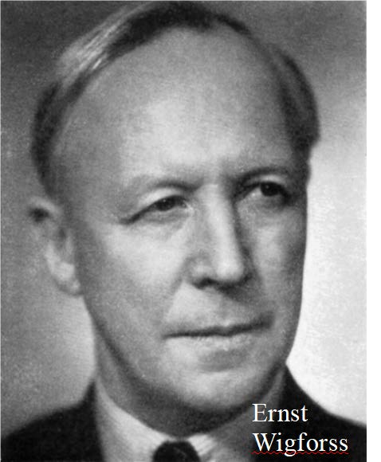
Wigforss was a Swedish politician and linguist. Born in the town Halmstad in Halland, he studied at Lund University and published different commentaries and articles on the political situation of the time. As a politician, his economic policies were strongly influenced by John Maynard Keynes, but even stronger influence of his ideas could be tracked to Knut Wicksell. He was one of the pioneers of Swedish social democracy and its revision from Marxism, and it is widely believed that his pamphlet Can we afford to work, where he mocked liberal policies, won the 1932 elections for Social Democrats. He was inspired and stood ideologically close to the ideas of the Fabian Society and guild socialism. He made contributions in his early writings about industrial democracy and workers' self-management, where he recognized the reformist potential against the otherwise revolutionary and violent socialist proposals.
There has not been any dearth of attempts to squeeze the labor contract entirely into the shape of an ordinary purchase-and-sale agreement. The worker sells his or her labor power and the employer pays an agreed price. What more could the worker demand, and how could he or she claim a part in the governance of the company? It has already been pointed out that the determination of the price can necessitate a consensual agreement on how the firm is managed. But, above all, from a labor perspective the invalidity of 23 the particular contract structure lies in its blindness to the fact that the labor power that the worker sells cannot like other commodities be separated from the living worker. This means that control over labor power must include control over the worker himself or herself. Here perhaps we meet the core of the whole modern labor question, and the way the problem is treated, and the perspectives from which it is judged, are what decide the character of the solutions. [Wigforss, Ernst. 1923. Den Industriella Demokratiens Problem 1. Stockholm: A.-B. Hasse W. Tullbergs boktryckeri, 28 (translation of the quotation by Patrik Witkowsky)]

Bertrand Russell (1872-1970)

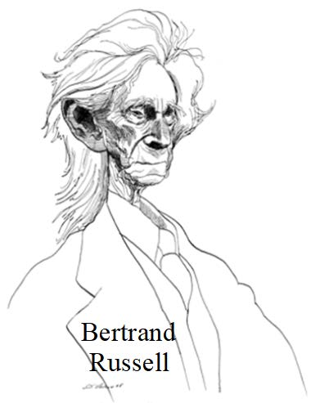
Russell was born in Wales into an influential and aristocratic British family with strong progressive-liberal values. Russell was a polymath. Today he is known as one of the most influential philosophers of the 20th century, one of the founders of analytic philosophy, but also a logician, mathematician, historian, writer, and political activist. He once described himself as liberal, socialist, and pacifist, without being overly invested in any of the categories; for example, while he was an anti-war activist, Russell supported the war against Hitler’s Nazi Germany as a necessary “lesser of two evils”. He talked about the paradox of tolerance, which he proposed to resolve by disallowing tolerance against the intolerant. He was strongly engaged in attempts of nuclear disbarment and, together with Einstein, wrote a manifesto signed by eleven of the other most prominent intellectuals of the time. While his engagement with political economy and political philosophy is not that well-known, he held a strong opinion about the need to democratize economic enterprises.
One very important step toward this end would be to render democratic the government of every organisation. At present, our legislative institutions are more or less democratic, except for the important fact that women are excluded.1 But our administration is still purely bureaucratic, and our economic organisations are monarchial or oligarchic. Every limited liability company is run by a small number of self-appointed or co-opted directors. There can be no real freedom or democracy until the men who do the work in a business also control its management. [Russell, Bertrand. 2003 (1917). Political Ideals. London: Routledge. p. 18; http://skepticva.org/Russell/polideal.htm]
The economic system we should ultimately wish to see would be one in which the state would be the sole recipient of economic rent, while private capitalistic enterprises should be replaced by self-governing combinations of those who actually do the work. [Ibid., p. 32]
The approach to a system free from these evils need not be sudden; it is perfectly possible to proceed step by step towards economic freedom and industrial self-government. It is not true that there is any outward difficulty in creating the kind of institutions that we have been considering. If organised labour wishes to create them, nothing could stand in its way. The difficulty involved is merely the difficulty of inspiring men with hope, of giving them enough imagination to see that the evils from which they suffer are unnecessary, and enough thought to understand how the evils are to be cured. This is a difficulty which can be overcome by time and energy. But it will not be overcome if the leaders of organised labour have no breadth of outlook, no vision, no hopes beyond some slight superficial improvement within the framework of the existing system. [Ibid., p. 36]

Justice Louis D. Brandeis (1856-1941)

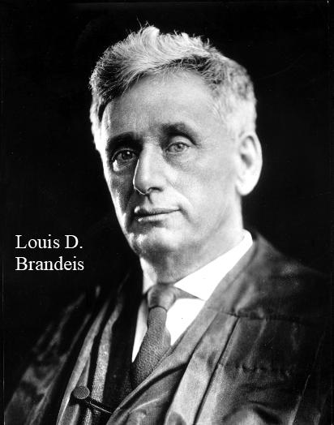
Justice Brandeis was born in Louisville Kentucky to a family of Jewish immigrants from Bohemia. After a distinguished career as a lawyer in Boston, he was nominated by President Woodrow Wilson to the Supreme Court where he became one of the most influential justices in the history of the Court. But his views on industrial democracy are relatively little-known.
The civilized world today believes that in the industrial world self-government is impossible; that we must adhere to the system which we have known as the monarchical system, the system of master and servant, or, as now more politely called, employer and employee. It rests with this century and perhaps with America to prove that as we have in the political world shown what self-government can do, we are to pursue the same lines in the industrial world. [Brandeis, Louis D. 1934. The Curse of Bigness. New York: Viking. p. 35]
Must not this mean that the American who is brought up with the idea of political liberty must surrender what every citizen deems far more important, his industrial liberty? Can this contradiction--our grand political liberty and this industrial slavery--long coexist? Either political liberty will be extinguished or industrial liberty must be restored. [Ibid., p. 39]
"In my judgement, we are going through the following stages: We already have had industrial despotism. With the recognition of the unions, this is changing into a constitutional monarchy, with well-defined limitations placed about the employer's formerly autocratic power. Next comes profit-sharing. This, however, is to be only a transitional, half-way stage. Following upon it will come the sharing of responsibility, as well as of profits. The eventual outcome promises to be full-grown industrial democracy. [Ibid., p. 47]
The great developer is responsibility. Hence no remedy can be hopeful which does devolve upon the workers participation in responsibility for the conduct of business; and their aim should be the eventual assumption of full responsibility--as in co-operative enterprises. This participation in and eventual control of industry is likewise an essential of obtaining justice in distributing the fruits of industry. [Ibid., p. 270]
The next generation must witness a continuing and ever-increasing contest between those who have and those who have not. The industrial word is in a state of ferment. The ferment is in the main peaceful, and, to a considerable extent, silent; but there is felt today very widely the inconsistency in this condition of political democracy and industrial absolutism. The people are beginning to doubt whether in the long run democracy and absolutism can coexist in the same community; beginning to doubt whether there is a justification for the great inequalities in the distribution of wealth, for the rapid creation of fortunes, more mysterious than the deeds of Aladdin's lamp. [Brandeis, Louis D. 1953. The Words of Justice Brandeis. Edited by Soloman Goldman. New York: Henry Schuman, p. 97]
In a democratic community we naturally long for that condition where labor will hire capital, instead of capital hiring labor. [Brandeis, Louis D. 1995. Brandeis on Democracy. Edited by Philippa Strum. Lawrence KS: University Press of Kansas. pp. 103-4]

Edwin G. Nourse (1883-1974)
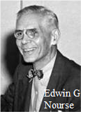
Edwin Nourse was an American economist who was the first Chairman of the newly-formed Council of Economic Advisors under the Truman presidency. Previously, he was the Vice-President of the Brookings Institution, and was the President of the American Economic Association in 1942. Some of his publications were about agricultural cooperation but he also published an article in the Yale Review (Spring 1942) which was reprinted as "Appendix B: Democracy as a Principle of Business" in his book Price Making in a Democracy. It was also printed as: Nourse, Edwin G. 1942. Democracy as a Principle of Business: Pamphlet 46. Washington DC: Brookings Institution.
The argument is essentially that in the post-war period, greater democracy in the workplace would draw forth more physical and mental efficiency from the workforce—an efficiency argument for more democracy. This rather common-sense argument made on an economic basis in 1942 stands in sharp contrast to so much of the modern conventional economic literature that tries to argue that more democracy in the workplace would be inefficient.
Let us suppose some representative system is devised by which all who are actively interested shall be able to participate in business enterprise. Perhaps less importance is to be attached to the bits of information and understanding the president or directors might thus get from the workers than to the wisdom that might be borne back from them to workers. If all those whose livelihood is dependent on the success of a business be given opportunity to discuss situations and problems of how everyone's bread is buttered. Representative spokesmen of wage earners returning from such conference would make for sound and conservative attitudes among their fellows when the rabble rouser who some times takes the place of intellectual leader in the hierarchy of union organization, would seek to lead labor on paths of self-destruction.
If working people are left in ignorance as to the true needs of business, that ignorance will express itself no less actively and probably somewhat more dangerously in the action that they take through their unions and through their endorsement of politicians and political proposals than it would if they were participating in a comprehensive discussion of business problems within the administrative system of the business on which they are dependent.
Some employers have already moderated the aristocratic claims of management and are seeking through a democracy of business enterprise to bring thoughtful and constructive participation to the masses, disfranchised under the predominant interpretation of free enterprise in business. Do they find labor so organized and thinking along such lines of economic democracy as would make for harmonious and effective attack on the basic problem of maximum production? Too often, no. [pp. 8-9]
The key to the direct and effective handling of the interrelated problem of capital and labor by farmer or handicraftsman is to be found in the fact that here the responsibility for the labor force and for the capital fund is one and indivisible. The same individual is capitalist, manager, and laborer. In our modern practice of private capitalism and free enterprise the trend has been, in large measure, to divest those who administer the capital fund from responsibility for the employment and material well-being of the labor force as a whole. When this tendency goes far enough, the two parts of the economic process fall apart and its functional integrity is lost. Restoration to this process, as fully as possible, of that democracy of participation, counsel, and control which were found when business units were still relatively small offers the best prospect of regaining the organic wholeness of a society of free enterprise for all. [pp. 22-23]
The economist, with eye single to the achieving of the greatest material well-being for the people as a whole, must reject whatever aristocratic pretentions have survived from earlier master-and-servant attitudes or have grown up amid the militant activities of swift and splendid industrial conquest. The power of our economic machine comes from the working contribution, physical and mental, of all its individual participants. Efficiency demands that we draw this power forth. But all these individuals are centers of personal interest as well as productive capacity. They coalesce in corporate companies, interest groups, economic classes, nationalistic political bodies aligned in every instance between "haves" and "have nots." Rival interests must be compromised to the common good. Democracy is a major biologic principle of economic life because it bases the health of the whole organism on the appropriate nourishment, stimulation, and co-ordination of every cell in its structural and functional relationship, whether it be of bone, tissue, or organ.
Our greatest hope for the end of this war is that world economy may be established on the basis of healthy organic relations between the several nations. We are pleased to talk of this federal union of democracies or—to use the older British phrase—commonwealths. But, as the latter term suggests, the strength of such a union will depend largely on the internal strength of its members —the extent to which they are able to settle for their own people the basic problems of class and group interest and to gain full strength through utilizing the resources of all their individual citizens. [pp. 23-24]

Harry von Eckermann (1886–1969)
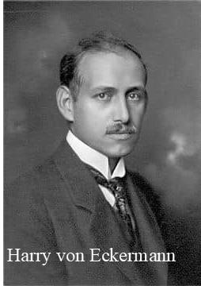
Harry von Eckermann was a Swedish industrialist, mineralogist, and geologist. He was also interested in theory and practice of economic organizations. As an industrialist, wrote a book: 1921. Industriell Demokrati. Fosterländska Ungdomsförbundets Skriftserie Nr. 4. Stockholm, which contained the following quotations (translations by Patrik Witkowsky).
The solution to the problem, I envisaged, is therefore based on the current corporation form and cooperative ownership form combined and, in short, means nothing but that the ownership of a company is gradually transferred to those who work in the company, i.e.. the same becomes cooperative - but instead of each individual as in the current cooperative movement receiving its share in the company, the transition thus takes place that the staff collectively become the owner of the shares through the members' annual payments. For example, for every worker or employee who is hired or found to be employed, 5 or 10 percent of the salary is deducted, which funds are pooled into a share redemption fund, which at the end of the year is disposed of for purchase after the redemption of shares existing on individual hands at a determined norm… . Thus the year-on-year increase in shareholding in the hands of the staff is managed as a special equity fund in which the return for each year each individual owns a share in proportion to the sum of his paid salary deduction during the period of employment at the company… [pp. 43-44]
The Board of Directors of the Equity Fund is elected on a set basis, - for example, votes in proportion to the work effort or year of operation of the company, - a certain number of personnel, representing different positions, after which the Board of Directors of this Equity Fund, in the usual order at the Annual General Meeting, monitors the interests of its clients, the total democratization of industrial capital practically coincides with corporate management. Thus, through this democratization, which is directly based on the two existing forms of organization, the limited company and the cooperative ownership, both a gradual transition to new industrial forms without any ruinous wear and tear between capital and labor, as well as a personal interest in the industry, is gained. the employee goes beyond the pay bag. The capital gets the actual real value of the shares, which at each redemption event is conditional on the greater or lesser development and success of each company - the employed body and thought worker receives both the economically and technically fostering opportunity to understand and understand his or her own detail the living conditions of industry. [p. 45]
At the same time, an association link is forged in practical application between the two choice languages of social democracy and bourgeoisie: "fruits of labor for those who work" and "Fruits of economy for those who save." For capital in the thus democratically industrialized society no longer receives the hallmark of predatory capital, but becomes an expression of a saved work result, a saving that is encouraged and legitimately made fruitful for the industry. development. The work reaches its fruits by putting the saved capital at its disposal, - not as a sharp cutting sword with the tip to the chest, but as a tool, which is returned after use, to be loaned to other promoters. [pp. 49-50].

Robert Dahl (1915-2014)
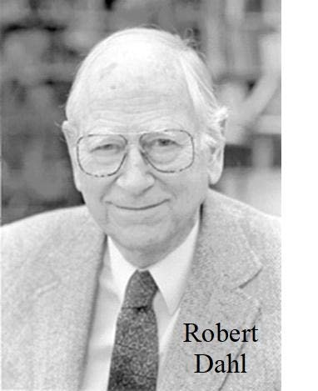
Robert Dahl was a political scientist who established a pluralist theory of democracy, which explains political outcomes by referring to a competitive process of different groups, possibly unequal in power. Today, Dahl is considered as one of the most influential political social scientists of the 20th century and has even been described as “the dean of American political scientists”. Dahl received his Ph.D. at Yale in 1940 and later became Sterling Professor at the same University. His perhaps best-known book, A Preface to Democratic Theory (1956), was followed years later by Preface to Economic Democracy (1985), where he develops his best defense of democratization of the workplace. Dahl considers an economic organization as analogous to a political organization, and hence subject to the same normative principles. If we demand of our nation states to be democratically governed, we should not simply drop this maxim when it comes to a different type of organization, for example the economic firm.
Sketch of an Alternative
I now want to consider a possible alternative: a system of economic enterprises collectively owned and democratically governed by all the people who work in them.* By democratically governed, I mean that within each enterprise decision making would be designed so far as possible to satisfy the criteria for the democratic process that I described in the preceding chapter, and thereby to achieve political equality and the protection of primary political rights within the firm. One crucially important feature of self governing enterprises, then, is that they satisfy the criterion of voting equality; hence each person employed in an enterprise is entitled to one and only one vote. Systems of this kind have been called workers' cooperatives or examples of self-management or industrial democracy; but I prefer the term self-governing enterprises.
* In clarifying my ideas on this question I have profited greatly from a number of unpublished papers by David Ellerman, cited in the bibliography, as well as numerous discussions with and papers by students in my graduate seminar on The Government of Economic Enterprises and my undergraduate seminar on Democracy at Work.” [Dahl, Robert. 1985. Preface to Economic Democracy. Berkeley: University of California Press. p. 91]

William Greider (1936-2019)
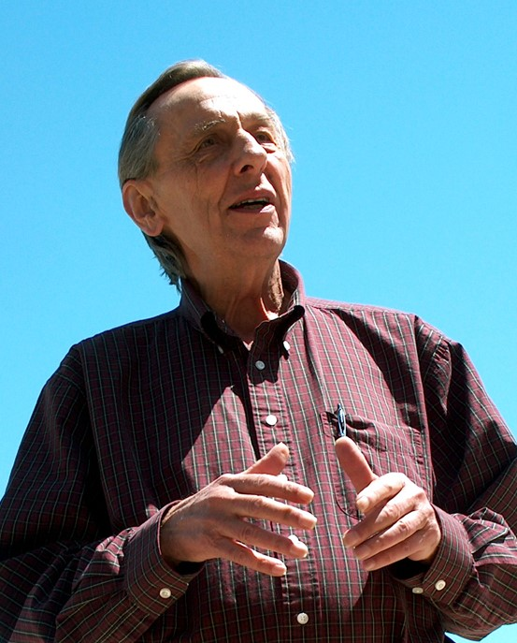
Bill Greider was born in Cincinnati Ohio. He was an economic journalist who last worked as the national affairs correspondent for The Nation. Greider was previously a reporter and editor at the Washington Post, where he, after the 2008 stock market crash, famously criticized the political response to the financial crisis, which was fueling taxpayers’ money to bring back more of the same instability. He authored a number of books, but the most relevant for our purposes was: Greider, William. 2003. The Soul of Capitalism: Opening Paths to a Moral Economy. New York: Simon & Schuster. The following quotation is from a more condensed treatment of the topic: Greider, William. 2005. “Reinventing the Corporation.” Seattle Journal for Social Justice 4 (1): 363–82.
“I have another model of ownership [of the corporation] to suggest. It is a different version of the ownership society that Bush talks about, but one that I doubt he will get too close to. I think the real owners, as opposed to the fictional ones, should be insiders. The real owners are the people who are close to the firm, who participate in it, and have a real stake in it and take real risks in that role, and who should also share equitably in the rewards. This means everybody. This means the employees; this means the major financial investors; it means the top management; it means the janitors; it means the chemists; the accountants; it means everybody. We can argue over the definitions, but the point is we need to break through what is really a remnant of feudalism—the master-servant relationship in the ownership of corporations.” [Ibid., p. 369]

Carole Pateman (1940-)

Carole Pateman was born in Sussex, England. She earned her PhD in Philosophy at Oxford University. She is a feminist scholar and a political theorist, and is the Distinguished Professor Emerita of Political Science at the University of California Los Angeles. She is perhaps the best known feminist democratic theorist, and, like Robert Dahl, she has been the president of the American Political Science Association. (Unlike Dahl, she was the first female president of the Association.) After several early books on Yugoslav self-management and participatory democracy, her work took a more feminist turn in what is probably her best-known work, The Sexual Contract (1988). But for our purposes here, we focus on her theory of participatory democracy in the workplace.
“Therefore, for a democratic polity to exist it is necessary for a participatory society to exist, i.e. a society where all political systems have been democratised and socialisation through participation can take place in all areas. The most important area is industry; most individuals spend a great deal of their lifetime at work and the business of the workplace provides an education in the management of collective affairs that it is difficult to parallel elsewhere. The second aspect of the theory of participatory democracy is that spheres such as industry should be seen as political systems in their own right, offering areas of participation additional to the national level. If individuals are to exercise the maximum amount of control over their own lives and environment then authority structures in these areas must be so organised that they can participate in decision making. A further reason for the central place of industry in the theory relates to the substantive measure of economic equality required to give the individual the independence and security necessary for (equal) participation; the democratising of industrial authority structures, abolishing the permanent distinction between ‘‘managers’’ and ‘‘men’’ would mean a large step toward meeting this condition.” [Pateman, Carole. 1970. Participation and Democratic Theory. Cambridge: Cambridge University Press. p. 43]

Noam Chomsky (1928-)
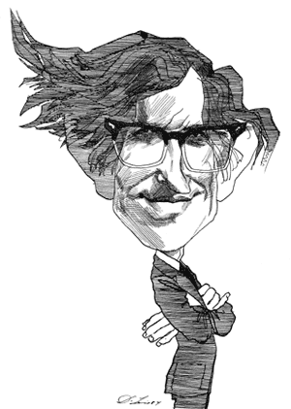
Noam Chomsky was born in Philadelphia, Pennsylvania. He is one of the central figures of modern analytical movements in philosophy, one of the central intellectuals of the 20th and 21st century, and a distinguished linguist (sometimes referred to as the “father of the modern linguistics”). He holds a joint appointment as Institute Professor Emeritus at the MIT in Boston and Laureate Professor at the University of Arizona. He aligns as anarcho-syndicalist and libertarian socialist. As such, he has long been a strong supporter of economic democracy as the third way of economic organization between capitalist and state-socialist institutions. Since 2018, Chomsky is a honorary member of the Experts’ Board at the Institute for Economic Democracy in Slovenia.
“If you have, say, worker-owned and -managed production facilities in communities which have popular budgeting and true democratic functioning, those support each other, and they can spread. In fact they might spread very fast. …
There are some, in fact, pretty substantial ones in the world like Mondragon—not perfect by any means, but a model that can be developed and extended here. I think it does appeal to people. We might just consider the matter of wage labor. It’s pretty hard to remember maybe, but if you go back to the early industrial revolutions, the late 19th century, wage labor was considered essentially the same as slavery. The only difference was that it was supposed to be temporary. That was a slogan of the Republican party: opposition to wage slavery. Why should some people give orders and others take them? That’s essentially the relation of a master and a slave, even if it could be temporary.
If you look back at the labor movement in the late 19th century, you see it had a rich array of worker-owned, worker-directed media: worker-written newspapers all over the place, and many of them by women—the so-called “factory girls” in textile plants. Attack on wage labor was constant. The slogan was, “Those who work in the mills should own them.” They opposed the degradation and undermining of culture that was part of the forced industrialization of the society. They began to link up with the radical agrarian movement. It was mostly still an agrarian society, the farmers groups that wanted to get rid of the northeastern bankers and merchants and run their own affairs. It was a really radical democratic moment.” [From an interview with the Next System Project: https://thenextsystem.org/conversation_with_noam_chomsky]
The remarkable quote from the labor press of the time is worth quoting in full.
When you sell your product, you retain your person. But when you sell your labour, you sell yourself, losing the rights of free men and becoming vassals of mammoth establishments of a monied aristocracy that threatens annihilation to anyone who questions their right to enslave and oppress. Those who work in the mills ought to own them, not have the status of machines ruled by private despots who are entrenching monarchic principles on democratic soil as they drive downwards freedom and rights, civilization, health, morals and intellectuality in the new commercial feudalism. [Quoted in: Chomsky, Noam. 2003. Chomsky on Democracy and Education. Edited by C. P. Otero. New York: RoutledgeFalmer. P. 29]
Chomsky elsewhere described the broader context for that quote.
And it has roots. Coming back to the United States, it has very strong roots in the American working class movements. So if you go back to, say, the 1850s, the beginnings of the Industrial Revolution, right around the area where I live, in Eastern Massachusetts, in the textile plants and so on, the people working on those plants were, in part, young women coming off the farm. They were called "factory girls," the women from the farms who worked in the textile plants. Some of them were Irish, immigrants in Boston and that group of people. They had an extremely rich and interesting culture. They're kind of like my uncle who never went past fourth grade -- very educated, reading modern literature. They didn't bother with European radicalism, that had no effect on them, but the general literary culture, they were very much a part of. And they developed their own conceptions of how the world ought to be organized.
They had their own newspapers. In fact, the period of the freest press in the United States was probably around the 1850s. In the 1850s, the scale of the popular press, meaning run by the factory girls in Lowell and so on, was on the scale of the commercial press or even greater. These were independent newspapers -- a lot of interesting scholarship on them, if you can read them now. They [arose] spontaneously, without any background. [The writers had] never heard of Marx or Bakunin or anyone else; they developed the same ideas. From their point of view, what they called "wage slavery," renting yourself to an owner, was not very different from the chattel slavery that they were fighting a civil war about. You have to recall that in the mid-nineteenth century, that was a common view in the United States -- for example, the position of the Republican Party, Abraham Lincoln's position. It's not an odd view, that there isn't much difference between selling yourself and renting yourself. So the idea of renting yourself, meaning working for wages, was degrading. It was an attack on your personal integrity. They despised the industrial system that was developing, that was destroying their culture, destroying their independence, their individuality, constraining them to be subordinate to masters. [From an interview: http://globetrotter.berkeley.edu/people2/Chomsky/chomsky-con2.html ]
A political tract from 1845 spelled out the idea for the “Lowells” and other industrial enterprises.
The direction and profits of industry [they said] must be kept in the hands of the producers. Laborers must own their own shops and factories, work their own stock, sell their own merchandise, and enjoy the fruits of their own toil. Our Lowells must be owned by the artisans who build them and the operatives who run the machinery and do all the work. And the dividend, instead of being given to the idle parasites of a. distant city, should be shared among those who perform the labor ... [Quoted in: Ware, Norman. 1964 (1924). The Industrial Worker 1840-1860. Chicago: Quadrangle. p. 186]

Concluding Remarks
All these thinkers, some better known than others, are not particularly known for their support for workplace democracy, but all of them are well-respected intellectuals, politicians, or businessmen whose ideas and actions had an impact on the modern world. Most of them saw economic democracy as a natural, ethical, and even efficient way to organize production, and it is amazing how little-known is this vision, which they supported. It is exactly because the mainstream left was caught in the socialist-capitalist dichotomy that TINA prevailed, and many think today that we are at “the end of history.” This it is only a matter of tinkering with the human rental system and its resulting distribution of income and wealth.
But there has always been an alternative to an employment system of human rentals. This paper sheds the light on overlooked defenders of this alternative, defenders who without any developed economic, legal, or moral theory or sectarian ideology, all saw the natural rightness of people jointly working for themselves in a democratic firm, rather than being a hired, rented, or employed person. And they said so.

S. Lawrence Bigelow, I. Leo Sharfman and R. M. Wenley (1922). Henry Carter Adams. Journal of Political Economy, Vol. 30, No. 2 (April 1922), pp. 201- 211.
Oxford English Dictionary.
Bankovsky, Miriam (2018). Alfred Marshall on Cooperation: Restraining the Cruel Force of Competition. History of Political Economy (2018) 50 (1): 49–81.
Stanford Encyclopedia of Philosophy. Entry: Jacques Maratain (Accessed on June 26th, 2020).

