Now available: The Oxford Handbook of Professional Economic Ethics

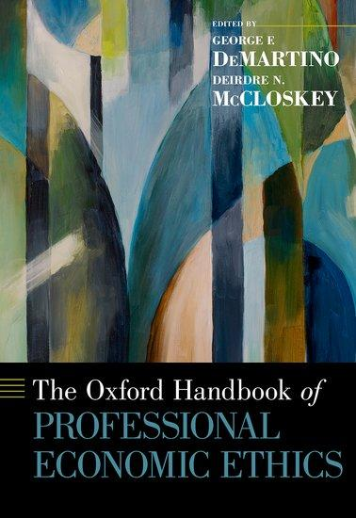

The Oxford Handbook of Professional Economic Ethics explores a wide range of questions related to the nature of ethical economic practice. The Handbook brings together new contributions of leading economists, professional ethicists, and others, all of whom probe here what it means to be an ethical economist, and what is required of economics to be a responsible profession. The Handbook widens substantially the terrain of economic ethics by examining the ethical entailments of academic and applied economic practice.

See Ellerman’s contribution here.

